Design Documentation:

Employee Management System:

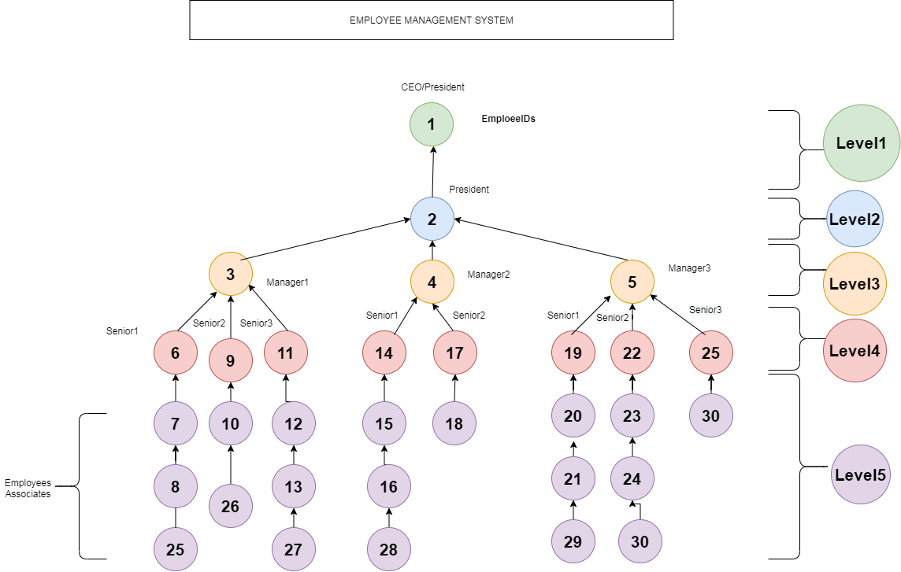

* The above diagram depicts employee management system architecture, where there will be top level employee who is CEO/President followed by other levels.
* There can be only one CEO/President at top level, which can be followed by any number of employees at any levels.
* The following conditions has to be satisfied to add employee into the system.
* Only top level employee can report to himself.
* Any number of employees can report to any number of superior employees.
* The top level employees cannot report to bottom level employees(For ex: employee with Id 2 -> of level 2 cannot report to of employee Id 15🡪 of level 5)
* While updating employee information if the employee contains (superior) other employees, reporting information cannot be updated unless the bottom level employees are dissolved or updated to other employees.

Below is the procedure to run employee management application:

FRONT END:

ALL EMPLOYEE LIST:

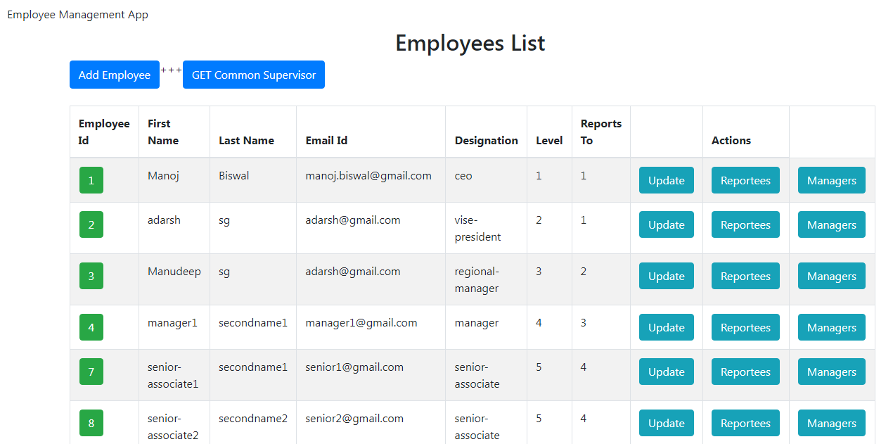

GET EMPLOYEE BY ID:

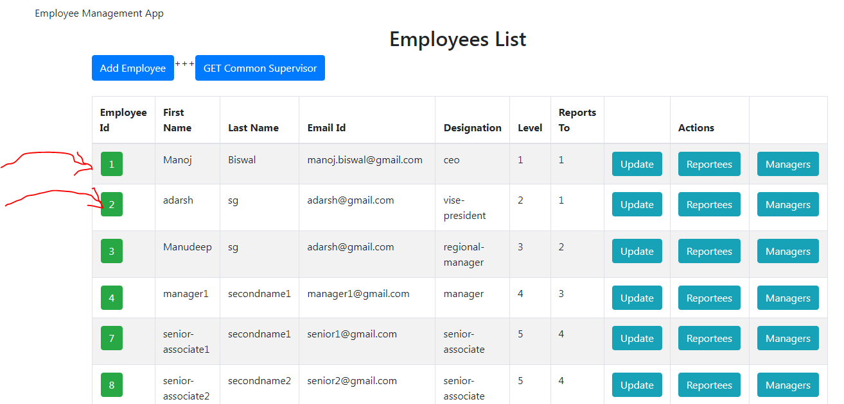

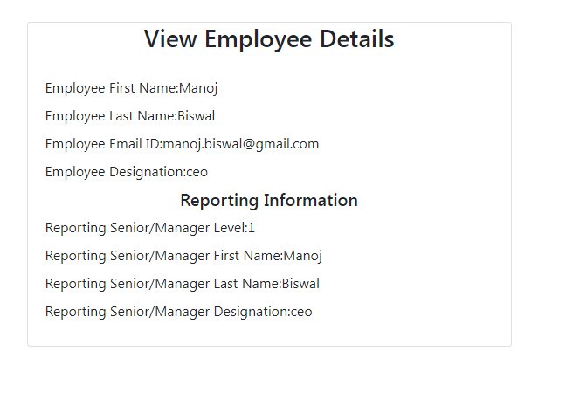

GET REPORTEES:

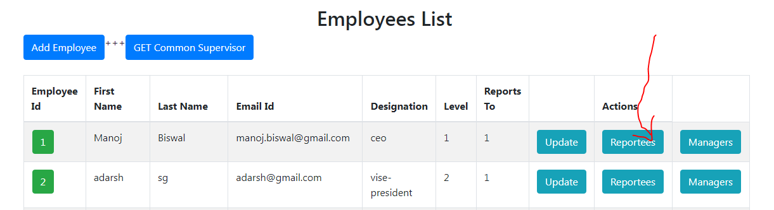

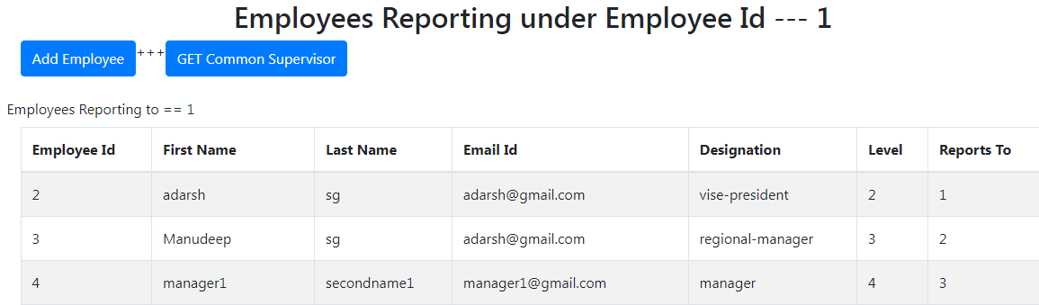

GET MANAGERS DIRECT OR INDIRECT:  
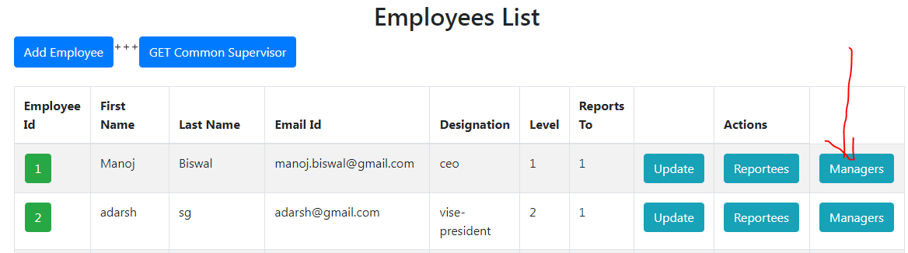

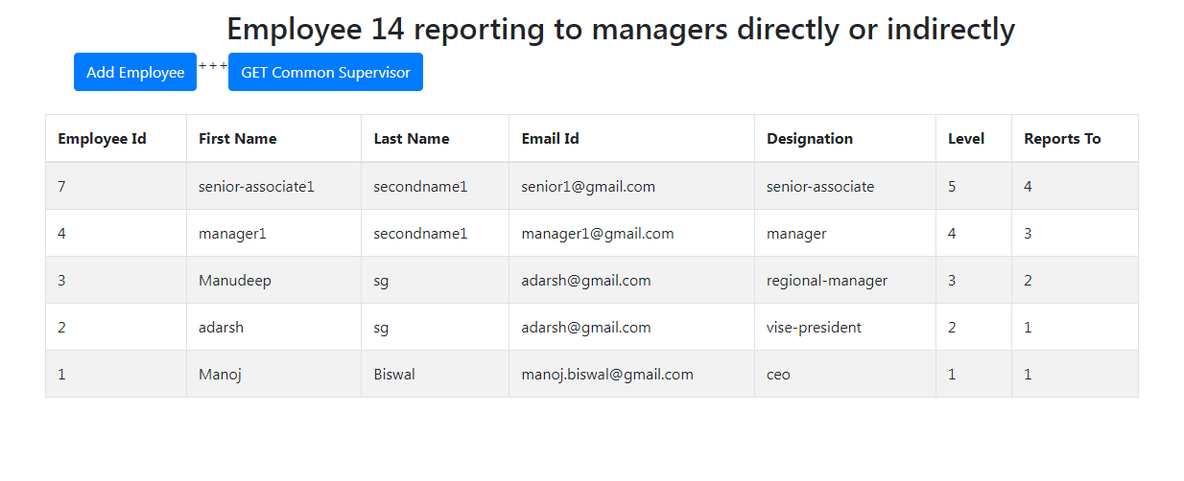

ADD EMPLOYEE:

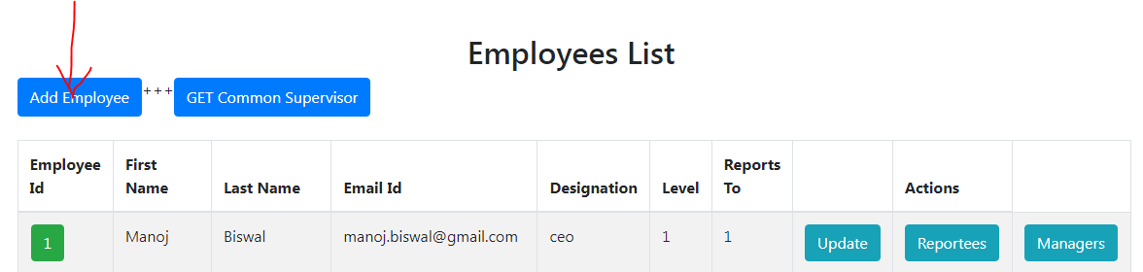

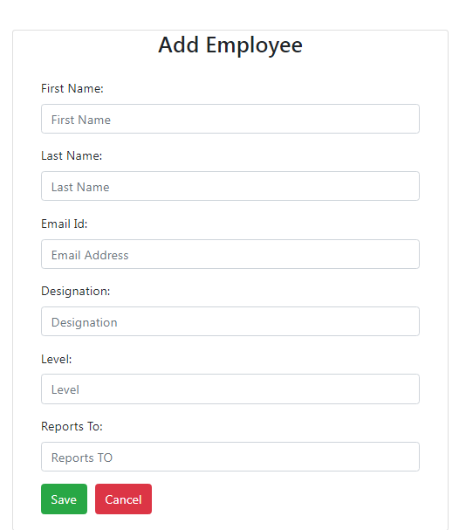

GET COMMON SUPERVISOR:

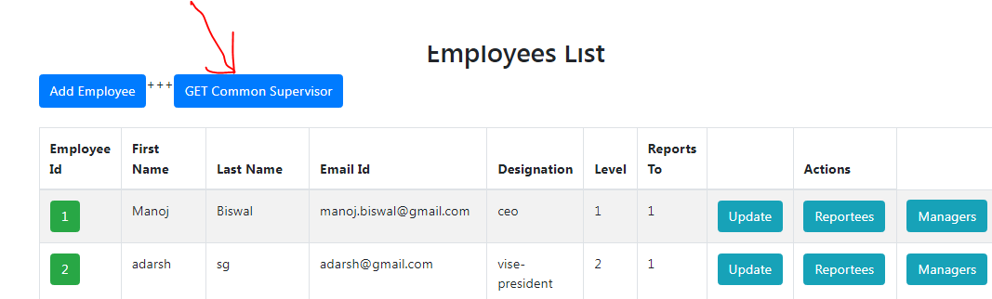

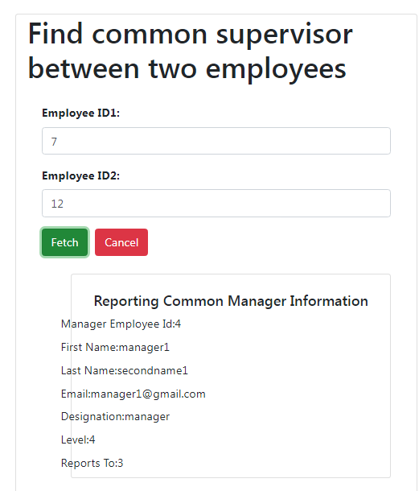

COMMON ERROR PAGE:

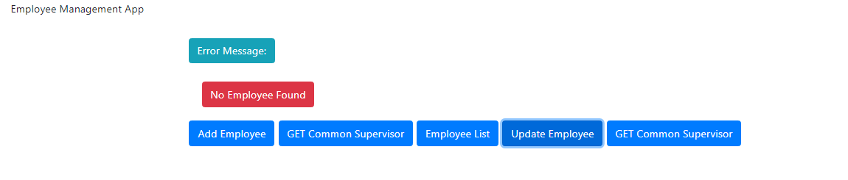

Sample insert queries:



Back-end end points along with response:

ADD EMPLOYEE:  
http://localhost:8083/employees/  
REQUEST BODY:

{

            "firstName": "Manoj",

            "lastName": "Biswal",

            "email": "manoj.ceo@gmail.com",

            "designation": "ceo",

            "level": 1,

            "reportsTo": 1

}

RESPONSE BODY:

{

    "status": "SUCCESS",

    "message": "Employee Added SuccessFully",

    "data": {

        "patientRef": {

            "id": 1,

            "firstName": "Manoj",

            "lastName": "Biswal",

            "email": "manoj.ceo@gmail.com",

            "designation": "ceo",

            "reportsTo": 1,

            "level": 1

        }

    }

}

PUT EMPLOYEES:  
REQUEST BODY:

{

            "firstName": "Manoj",

            "lastName": "Biswal",

            "email": "manoj.biswal@gmail.com",

            "designation": "ceo",

            "level": 1,

            "reportsTo": 1

}

RESPONSE BODY:

{

            "firstName": "Manoj",

            "lastName": "Biswal",

            "email": "manoj.bapyee@gmail.com",

            "designation": "trainee",

            "level": 6,

            "reportsTo": 7

}

GET ALL EMPLOYEES:

<http://localhost:8083/employees/>

{

    "status": "SUCCESS",

    "message": "Below is information of the employee",

    "data": {

        "getEmployee": [

            {

                "id": 1,

                "firstName": "nikhil",

                "lastName": "sg",

                "email": "nik@gmail.com",

                "designation": "chairman",

                "reportsTo": 1,

                "level": 1

            },

            {

                "id": 2,

                "firstName": "adarsh",

                "lastName": "sg",

                "email": "adarsh@gmail.com",

                "designation": "vise-president",

                "reportsTo": 1,

                "level": 2

            },

            {

                "id": 3,

                "firstName": "Manudeep",

                "lastName": "sg",

                "email": "adarsh@gmail.com",

                "designation": "regional-manager",

                "reportsTo": 2,

                "level": 3

            },

            {

                "id": 4,

                "firstName": "manager1",

                "lastName": "secondname1",

                "email": "manager1@gmail.com",

                "designation": "manager",

                "reportsTo": 3,

                "level": 4

            },

            {

                "id": 5,

                "firstName": "manager2",

                "lastName": "secondname2",

                "email": "manager2@gmail.com",

                "designation": "manager",

                "reportsTo": 3,

                "level": 4

            },

            {

                "id": 6,

                "firstName": "manager3",

                "lastName": "secondname3",

                "email": "manager3@gmail.com",

                "designation": "manager",

                "reportsTo": 3,

                "level": 4

            },

            {

                "id": 7,

                "firstName": "senior-associate1",

                "lastName": "secondname1",

                "email": "senior1@gmail.com",

                "designation": "senior-associate",

                "reportsTo": 4,

                "level": 5

            },

            {

                "id": 8,

                "firstName": "senior-associate2",

                "lastName": "secondname2",

                "email": "senior2@gmail.com",

                "designation": "senior-associate",

                "reportsTo": 4,

                "level": 5

            },

            {

                "id": 9,

                "firstName": "senior-associate1",

                "lastName": "secondname1",

                "email": "senior1@gmail.com",

                "designation": "senior-associate",

                "reportsTo": 5,

                "level": 5

            },

            {

                "id": 10,

                "firstName": "senior-associate1",

                "lastName": "secondname1",

                "email": "senior1@gmail.com",

                "designation": "senior-associate",

                "reportsTo": 6,

                "level": 5

            },

            {

                "id": 11,

                "firstName": "senior-associate2",

                "lastName": "secondname2",

                "email": "senior2@gmail.com",

                "designation": "senior-associate",

                "reportsTo": 6,

                "level": 5

            },

            {

                "id": 12,

                "firstName": "trainee1",

                "lastName": "secondname1",

                "email": "trainee1@gmail.com",

                "designation": "trainee",

                "reportsTo": 7,

                "level": 6

            },

            {

                "id": 13,

                "firstName": "trainee2",

                "lastName": "secondname2",

                "email": "trainee2@gmail.com",

                "designation": "trainee",

                "reportsTo": 7,

                "level": 6

            },

            {

                "id": 14,

                "firstName": "trainee3",

                "lastName": "secondname3",

                "email": "trainee3@gmail.com",

                "designation": "trainee",

                "reportsTo": 7,

                "level": 6

            },

            {

                "id": 15,

                "firstName": "trainee4",

                "lastName": "secondname4",

                "email": "trainee4@gmail.com",

                "designation": "trainee",

                "reportsTo": 7,

                "level": 6

            },

            {

                "id": 16,

                "firstName": "trainee16",

                "lastName": "secondname1",

                "email": "trainee16@gmail.com",

                "designation": "trainee",

                "reportsTo": 8,

                "level": 6

            },

            {

                "id": 17,

                "firstName": "trainee17",

                "lastName": "secondname2",

                "email": "trainee17@gmail.com",

                "designation": "trainee",

                "reportsTo": 8,

                "level": 6

            },

            {

                "id": 18,

                "firstName": "trainee18",

                "lastName": "secondname3",

                "email": "trainee18@gmail.com",

                "designation": "trainee",

                "reportsTo": 8,

                "level": 6

            },

            {

                "id": 19,

                "firstName": "trainee19",

                "lastName": "secondname4",

                "email": "trainee19@gmail.com",

                "designation": "trainee",

                "reportsTo": 8,

                "level": 6

            },

            {

                "id": 20,

                "firstName": "trainee20",

                "lastName": "secondname1",

                "email": "trainee20@gmail.com",

                "designation": "trainee",

                "reportsTo": 9,

                "level": 6

            },

            {

                "id": 21,

                "firstName": "trainee21",

                "lastName": "secondname2",

                "email": "trainee21@gmail.com",

                "designation": "trainee",

                "reportsTo": 9,

                "level": 6

            },

            {

                "id": 22,

                "firstName": "trainee22",

                "lastName": "secondname1",

                "email": "trainee22@gmail.com",

                "designation": "trainee",

                "reportsTo": 10,

                "level": 6

            },

            {

                "id": 23,

                "firstName": "trainee23",

                "lastName": "secondname2",

                "email": "trainee23@gmail.com",

                "designation": "trainee",

                "reportsTo": 10,

                "level": 6

            },

            {

                "id": 24,

                "firstName": "trainee24",

                "lastName": "secondname3",

                "email": "trainee24@gmail.com",

                "designation": "trainee",

                "reportsTo": 10,

                "level": 6

            },

            {

                "id": 25,

                "firstName": "trainee25",

                "lastName": "secondname4",

                "email": "trainee25@gmail.com",

                "designation": "trainee",

                "reportsTo": 10,

                "level": 6

            }

        ]

    }

}

GET EMPLOYEE BY ID:  
<http://localhost:8083/employees/3>

{

    "status": "SUCCESS",

    "message": "Below is information of the employee",

    "data": {

        "getEmployee": {

            "id": 3,

            "firstName": "Manudeep",

            "lastName": "sg",

            "email": "adarsh@gmail.com",

            "designation": "regional-manager",

            "level": 3,

            "reportsTo": {

                "level": 2,

                "firstName": "adarsh",

                "lastName": "sg",

                "designation": "vise-president"

            }

        }

    }

}

GET REPORTEES UNDER EMPLOYEE:  
<http://localhost:8083/employees/3/reportees>

{

    "status": "SUCCESS",

    "message": "Information under reportees",

    "data": {

        "reporteesDirectAndIndirect": [

            {

                "id": 4,

                "firstName": "manager1",

                "lastName": "secondname1",

                "email": "manager1@gmail.com",

                "designation": "manager",

                "reportsTo": 3,

                "level": 4

            },

            {

                "id": 5,

                "firstName": "manager2",

                "lastName": "secondname2",

                "email": "manager2@gmail.com",

                "designation": "manager",

                "reportsTo": 3,

                "level": 4

            },

            {

                "id": 6,

                "firstName": "manager3",

                "lastName": "secondname3",

                "email": "manager3@gmail.com",

                "designation": "manager",

                "reportsTo": 3,

                "level": 4

            },

            {

                "id": 7,

                "firstName": "senior-associate1",

                "lastName": "secondname1",

                "email": "senior1@gmail.com",

                "designation": "senior-associate",

                "reportsTo": 4,

                "level": 5

            },

            {

                "id": 8,

                "firstName": "senior-associate2",

                "lastName": "secondname2",

                "email": "senior2@gmail.com",

                "designation": "senior-associate",

                "reportsTo": 4,

                "level": 5

            },

            {

                "id": 12,

                "firstName": "trainee1",

                "lastName": "secondname1",

                "email": "trainee1@gmail.com",

                "designation": "trainee",

                "reportsTo": 7,

                "level": 6

            },

            {

                "id": 13,

                "firstName": "trainee2",

                "lastName": "secondname2",

                "email": "trainee2@gmail.com",

                "designation": "trainee",

                "reportsTo": 7,

                "level": 6

            },

            {

                "id": 14,

                "firstName": "trainee3",

                "lastName": "secondname3",

                "email": "trainee3@gmail.com",

                "designation": "trainee",

                "reportsTo": 7,

                "level": 6

            },

            {

                "id": 15,

                "firstName": "trainee4",

                "lastName": "secondname4",

                "email": "trainee4@gmail.com",

                "designation": "trainee",

                "reportsTo": 7,

                "level": 6

            },

            {

                "id": 16,

                "firstName": "trainee16",

                "lastName": "secondname1",

                "email": "trainee16@gmail.com",

                "designation": "trainee",

                "reportsTo": 8,

                "level": 6

            },

            {

                "id": 17,

                "firstName": "trainee17",

                "lastName": "secondname2",

                "email": "trainee17@gmail.com",

                "designation": "trainee",

                "reportsTo": 8,

                "level": 6

            },

            {

                "id": 18,

                "firstName": "trainee18",

                "lastName": "secondname3",

                "email": "trainee18@gmail.com",

                "designation": "trainee",

                "reportsTo": 8,

                "level": 6

            },

            {

                "id": 19,

                "firstName": "trainee19",

                "lastName": "secondname4",

                "email": "trainee19@gmail.com",

                "designation": "trainee",

                "reportsTo": 8,

                "level": 6

            },

            {

                "id": 9,

                "firstName": "senior-associate1",

                "lastName": "secondname1",

                "email": "senior1@gmail.com",

                "designation": "senior-associate",

                "reportsTo": 5,

                "level": 5

            },

            {

                "id": 20,

                "firstName": "trainee20",

                "lastName": "secondname1",

                "email": "trainee20@gmail.com",

                "designation": "trainee",

                "reportsTo": 9,

                "level": 6

            },

            {

                "id": 21,

                "firstName": "trainee21",

                "lastName": "secondname2",

                "email": "trainee21@gmail.com",

                "designation": "trainee",

                "reportsTo": 9,

                "level": 6

            },

            {

                "id": 10,

                "firstName": "senior-associate1",

                "lastName": "secondname1",

                "email": "senior1@gmail.com",

                "designation": "senior-associate",

                "reportsTo": 6,

                "level": 5

            },

            {

                "id": 11,

                "firstName": "senior-associate2",

                "lastName": "secondname2",

                "email": "senior2@gmail.com",

                "designation": "senior-associate",

                "reportsTo": 6,

                "level": 5

            },

            {

                "id": 22,

                "firstName": "trainee22",

                "lastName": "secondname1",

                "email": "trainee22@gmail.com",

                "designation": "trainee",

                "reportsTo": 10,

                "level": 6

            },

            {

                "id": 23,

                "firstName": "trainee23",

                "lastName": "secondname2",

                "email": "trainee23@gmail.com",

                "designation": "trainee",

                "reportsTo": 10,

                "level": 6

            },

            {

                "id": 24,

                "firstName": "trainee24",

                "lastName": "secondname3",

                "email": "trainee24@gmail.com",

                "designation": "trainee",

                "reportsTo": 10,

                "level": 6

            },

            {

                "id": 25,

                "firstName": "trainee25",

                "lastName": "secondname4",

                "email": "trainee25@gmail.com",

                "designation": "trainee",

                "reportsTo": 10,

                "level": 6

            }

        ]

    }

}

GET DIRECT AND INDIRECT MANAGERS OF EMPLOYEE:   
<http://localhost:8083/employees/8/managers>

{

    "status": "SUCCESS",

    "message": "Information of Employees reporting to managers",

    "data": {

        "managersDirectAndIndirect": [

            {

                "id": 4,

                "firstName": "manager1",

                "lastName": "secondname1",

                "email": "manager1@gmail.com",

                "designation": "manager",

                "reportsTo": 3,

                "level": 4

            },

            {

                "id": 3,

                "firstName": "Manudeep",

                "lastName": "sg",

                "email": "adarsh@gmail.com",

                "designation": "regional-manager",

                "reportsTo": 2,

                "level": 3

            },

            {

                "id": 2,

                "firstName": "adarsh",

                "lastName": "sg",

                "email": "adarsh@gmail.com",

                "designation": "vise-president",

                "reportsTo": 1,

                "level": 2

            },

            {

                "id": 1,

                "firstName": "nikhil",

                "lastName": "sg",

                "email": "nik@gmail.com",

                "designation": "chairman",

                "reportsTo": 1,

                "level": 1

            }

        ]

    }

}

GET COMMON SUPERVISOR(NEED NOT BE IMMEDIATE)

<http://localhost:8083/employees/supervisor/7/12>

{

    "status": "SUCCESS",

    "message": "Information under reportees",

    "data": {

        "commonSupervisor": {

            "employeeId": 4,

            "firstName": "manager1",

            "lastName": "secondname1",

            "email": "manager1@gmail.com",

            "designation": "manager",

            "level": 4,

            "reportsTo": 3

        }

    }

}